H.T No
Regulations:
A18

Sreenidhi Institute of Science and Technology
(An Autonomous Institution)
Code No: 7A201 Date: 09-August-2024 (FN)

B.Tech I-Year II- Semester External Examination, August - 2024 (Supplementary)
ELECTRICAL CIRCUITS AND NETWORKS-I (EEE)

Time: 3 Hours Max.Marks:70

Note: a) No additional answer sheets will be provided.
b) All sub-parts of a question must be answered at one place only, otherwise it will not be valued.
c) Missing data can be assumed suitably.

Bloom's Cognitive Levels of Learning (BCLL)

Remember | L1 | Apply | L3 | Evaluate | L5
Understand | L2 | Analyze | L4 | Create | L6

Part - A Max.Marks:20
Answer all QUESTIONS

 |  | BCLL | CO(s) | Marks
1 | Convert the given delta connected network into star network  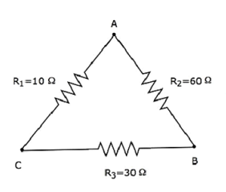 | L2 | CO1 | [2M]
2 | Draw the dual network for the following  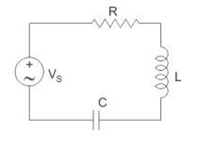 | L3 | CO2 | [2M]
3 | State Faraday’s laws of electromagnetic induction. | L1 | CO3 | [2M]
4 | What is the significance of J notation | L2 | CO4 | [2M]
5 | Define Resonance. | L1 | CO5 | [2M]
6 | State Superposition theorem | L1 | CO6 | [2M]
7 | Draw the graph for below Network  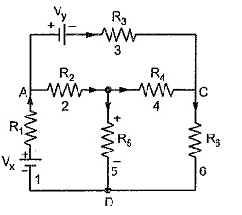 | L1 | CO | [2M]
8 | What is the significance of Dot convention | L2 | CO | [2M]
9 | Draw the Locus diagram for series R-L circuit | L1 | CO | [2M]
10 | Find the unknown currents.  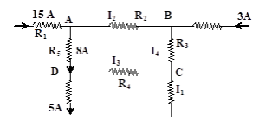 | L3 | CO | [2M]
Part – B Max.Marks:50
ANSWER ANY FIVE QUESTIONS. EACH QUESTION CARRIES 10 MARKS.

 |  |  | BCLL | CO(s) | Marks
11. | a) | Find the voltage across 30 Ω resistor using Mesh analysis.  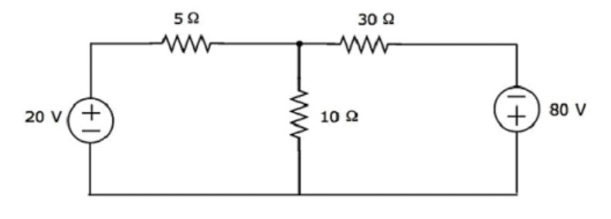 | L3 | CO1 | [5M]
 | b) | Explain Kirchoff’s laws with suitable example. | L2 | CO1 | [5M]
12. | a) | For the network shown below, draw the graph and derive the cutset matrix.  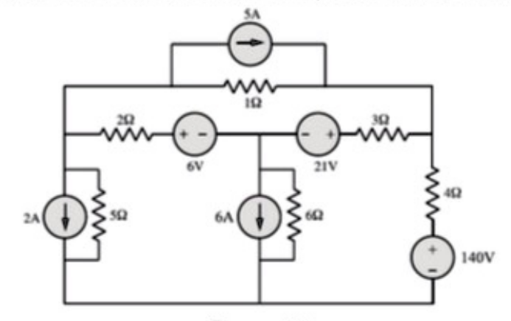 | L4 | CO2 | [5M]
 | b) | Define Graph, tree and incident matrix with examples. | L1 | CO2 | [5M]
13. | a) | Explain the concept of self and mutual inductance. | L2 | CO3 | [5M]
 | b) | Two inductors have self-inductances of 5 mH and 10 mH and mutual inductance between the two is 5 mH. Find the equivalent inductance when they are connected in parallel opposing and in series aiding. | L3 | CO3 | [5M]
14. | a) | Derive form factor for a sinusoidally alternating voltage waveform | L3 | CO4 | [5M]
 | b) | A resistance of 10 ohm is connected in series with 50mH inductor across a 230v,50Hz supply. Calculate 1. Current flowing in the circuit 2. Phase angle  3. Voltage across resistor and inductor 4. Active and Reactive power | L3 | CO4 | [5M]
15. | a) | Consider the parallel RLC circuit shown below  1.Find the Resonant frequency  2.Calculate the Quality factor and Bandwidth  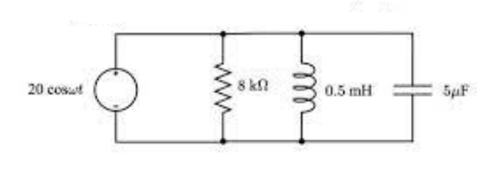 | L3 | CO5 | [5M]
 | b) | What is the significance of Locus Diagrams? And draw the locus diagram for series R-C circuit with variation of various parameters. | L4 | CO5 | [5M]
16. | a) | Find the maximum power that can be delivered to the load resistor R_{L} of the circuit shown in the following figure.  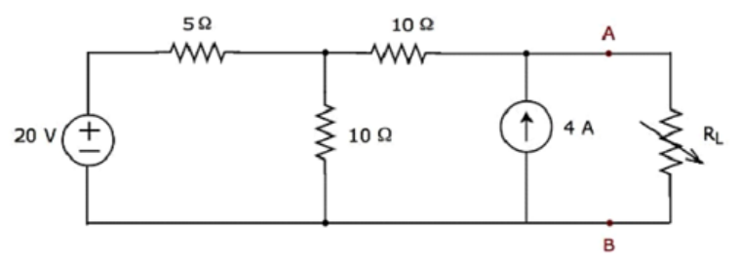 | L4 | CO6 | [5M]
 | b) | Find the current and voltage in the below circuit using Milliman’s theorem.  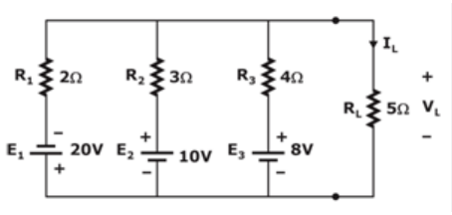 | L4 | CO6 | [5M]
17. | a) | Classify independent and dependent sources. | L3 | CO1 | [4M]
 | b) | Draw the tree for the following network  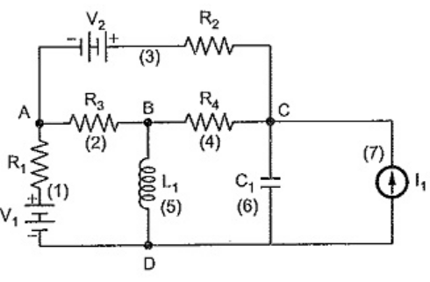 | L4 | CO2 | [3M]
 | c) | Distinguish between Electrical and Magnetic circuits | L2 | CO3 | [3M]
18. | a) | Determine the equivalent impedance for the following circuit.  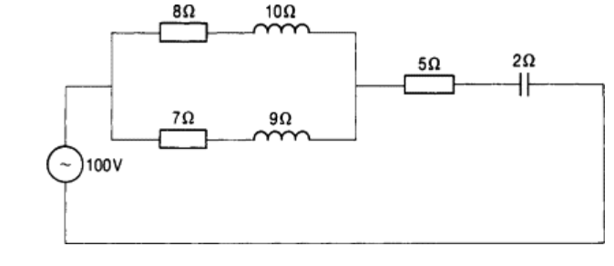 | L3 | CO4 | [4M]
 | b) | Obtain resonance condition for series R-L-C Circuit. | L5 | CO5 | [3M]
 | c) | State maximum power transfer theorem. | L1 | CO6 | [3M]
-- 00 -- 00 –

